**Assignment 1: Types of Network Topology**

The arrangement of a network that comprises nodes and connecting lines via sender and receiver is referred to as Network Topology. The various network topologies are:

* Point to Point Topology
* Mesh Topology
* Star Topology
* Bus Topology
* Ring Topology
* Tree Topology
* Hybrid Topology

Point to Point Topology

[Point-to-Point Topology](https://www.geeksforgeeks.org/difference-between-point-to-point-link-and-star-topology-network/) is a type of topology that works on the functionality of the sender and receiver. It is the simplest communication between two nodes, in which one is the sender and the other one is the receiver. Point-to-Point provides high bandwidth.

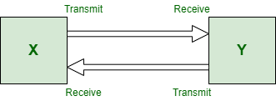

Mesh Topology

In a mesh topology, every device is connected to another device via a particular channel. In [Mesh Topology](https://www.geeksforgeeks.org/difference-between-star-and-mesh-topology/), the protocols used are AHCP (Ad Hoc Configuration Protocols), DHCP (Dynamic Host Configuration Protocol), etc.

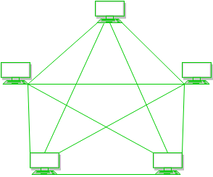

Star Topology

In [Star Topology](https://www.geeksforgeeks.org/difference-between-star-and-ring-topology/), all the devices are connected to a single hub through a cable. This hub is the central node and all other nodes are connected to the central node. The hub can be passive in nature i.e., not an intelligent hub such as broadcasting devices, at the same time the hub can be intelligent known as an active hub. Active hubs have repeaters in them. Coaxial cables or RJ-45 cables are used to connect the computers. In Star Topology, many popular Ethernet LAN protocols are used as CD(Collision Detection), CSMA (Carrier Sense Multiple Access), etc.

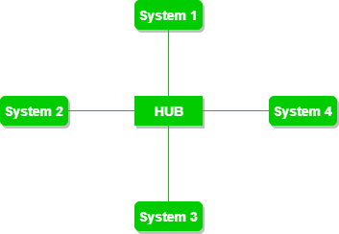

Bus Topology

[Bus Topology](https://www.geeksforgeeks.org/difference-between-star-topology-and-bus-topology/) is a network type in which every computer and network device is connected to a single cable. It is bi-directional. It is a multi-point connection and a non-robust topology because if the backbone fails the topology crashes. In Bus Topology, various MAC (Media Access Control) protocols are followed by LAN ethernet connections like TDMA, Pure Aloha, CDMA, Slotted Aloha, etc.

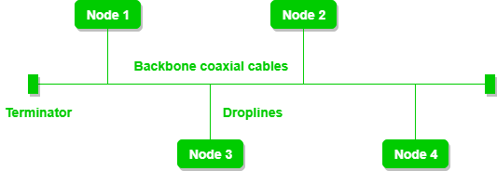

Ring Topology

In a [Ring Topology](https://www.geeksforgeeks.org/difference-between-ring-topology-and-tree-topology/), it forms a ring connecting devices with exactly two neighbouring devices. A number of repeaters are used for Ring topology with a large number of nodes, because if someone wants to send some data to the last node in the ring topology with 100 nodes, then the data will have to pass through 99 nodes to reach the 100th node. Hence to prevent data loss repeaters are used in the network.

The data flows in one direction, i.e. it is unidirectional, but it can be made bidirectional by having 2 connections between each Network Node, it is called Dual Ring Topology. In-Ring Topology, the Token Ring Passing protocol is used by the workstations to transmit the data.

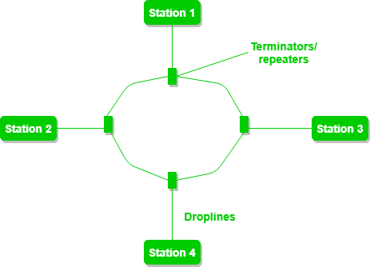

Tree Topology

Also known as Hierarchical Topology, this is the most common form of network topology in use presently. This topology imitates as extended Star topology and inherits properties of bus topology.

This topology divides the network in to multiple levels/layers of network. Mainly in LANs, a network is bifurcated into three types of network devices.

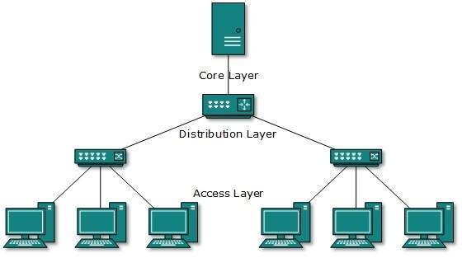

Hybrid Topology

A network structure whose design contains more than one topology is said to be hybrid topology. Hybrid topology inherits merits and demerits of all the incorporating topologies. The combining topologies may contain attributes of Star, Ring, Bus topologies.